**DEPARTMENT OF COMPUTER & SOFTWARE ENGINEERING**

**COLLEGE OF E&ME, NUST, RAWALPINDI**

**Subject Name**

**Digital Image Processing**

**Lab Number**

**3**

**SUBMITTED TO:**

**Dr. Asad Khan**

**LE Sundas Ashraf**

**SUBMITTED BY:**

**Student Name**

1. Wahaaj Nasir

**Reg#413238**

**DE- 44 Dept C&SE**

**Objectives:**

Basics of Image Processing in Python

**Related Topic/Chapter in theory class:**

Basics Of Digital Image Processing

**Hardware/Software required:**

Hardware: PC

Software Tool: Pycharm

**Task 3:**

**Apply Power Law transformation for the following values of γ (0.2, 0.5, 1.2 and 1.8) . Make sure to adjust data types accordingly. Also apply log (log10) transformation on the images.**

**Solution:**

import numpy as np  
import cv2 as cv  
import math  
  
def transform_power(image):  
 rows, cols = image.shape  
 img1 = np.zeros((rows, cols), dtype=np.uint8)  
 img2 = np.zeros((rows, cols), dtype=np.uint8)  
 img3 = np.zeros((rows, cols), dtype=np.uint8)  
 img4 = np.zeros((rows, cols), dtype=np.uint8)  
  
 *#Gamma = 0.2* for i in range(rows):  
 for j in range(cols):  
 r = image[i][j]  
 s = int(255 * ((r/255)**0.2))  
 img1[i][j] = s  
  
 *#Gamma = 0.5* for i in range(rows):  
 for j in range(cols):  
 r = image[i][j]  
 s = int(255 * ((r/255)**0.5))  
 img2[i][j] = s  
  
 *#Gamma = 1.2* for i in range(rows):  
 for j in range(cols):  
 r = image[i][j]  
 s = int(255 * ((r/255)**1.2))  
 img3[i][j] = s  
  
 *#Gamma = 1.8* for i in range(rows):  
 for j in range(cols):  
 r = image[i][j]  
 s = int(255 * ((r/255)**1.8))  
 img4[i][j] = s  
  
 cv.imshow('Original', image)  
 cv.imshow('Gamma 0.2', img1)  
 cv.imshow('Gamma 0.5', img2)  
 cv.imshow('Gamma 1.2', img3)  
 cv.imshow('Gamma 1.8', img4)  
 cv.waitKey()  
  
def log_transform(image):  
 c = 255 /np.log10(1+int(np.max(image))) *#1+255 in np.max returns 0 as it wraps around* rows, cols = image.shape  
 new_img = np.zeros((rows, cols), dtype=np.uint8)  
  
 for i in range(rows):  
 for j in range(cols):  
 r = int(image[i][j])  
 s = c * (np.log10(r+1))  
 new_img[i][j] = np.uint8(s)  
  
 return new_img  
  
*#Main*image = cv.imread("D:/Uni/Semester 6/DIP/Self/Lab/Lab 3/Lab 3/fig03.tif", 0)  
transform_power(image)  
log_img = log_transform(image)  
  
print(np.max(image))  
cv.imshow('Log Transform', log_img)  
cv.waitKey()

**Output:**

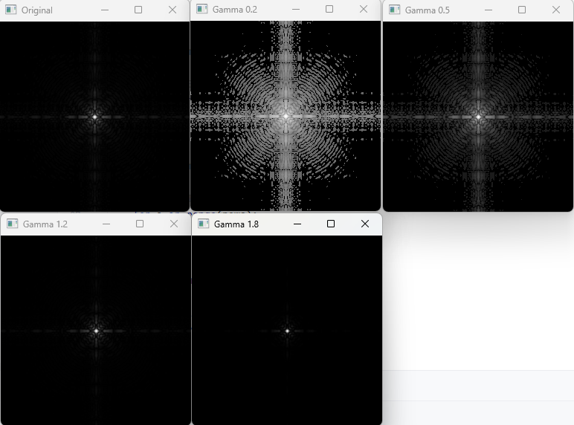

**Gamma Results**

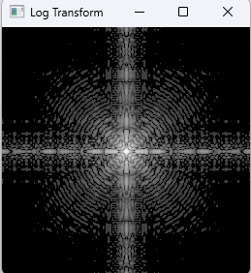

**Log Transform**